What Can We Taste?

For this activity you will be working in pairs. You will take turns to try different food while you close your eyes without peeking. Just using your taste , try to work out what the foods are. Your partner will write a number in the box next to the picture showing the food in the order you guessed.

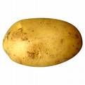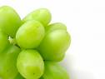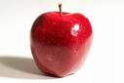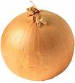

potato grape apple onion

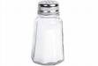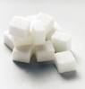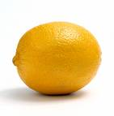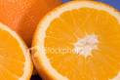

salt sugar lemon orange

